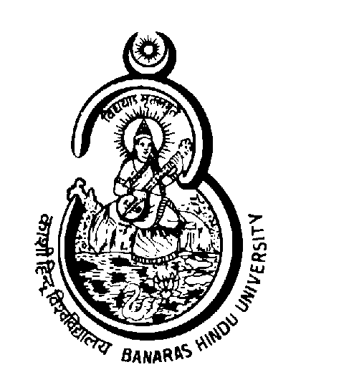 | Banaras Hindu University  Varanasi - 221 005  (Established by Parliament by Notification No. 225 of 1916)
Walk-in-interview
Eligible Candidates, along with full Bio-data with a photograph affixed and photocopies of Certificate/Mark-sheets annexed to it, are requested to attend a Walk-in-Interview on 06.12.2010 at 10.00 AM in the Holkar House, BHU, Varanasi for engagement as (1) Engineering Assistant (Civil), (2) Engineering Assistant (Mechanical) and (3) Engineering Assistant (Electrical) (on a fixed remuneration of Rs. 16000/- p.m.) on Contractual Basis initially for a period of 01 year in Rajiv Gandhi South Campus, Barkachha, Mirzapur.
Qualifications:
Minimum 05 years experience for Diploma Engineers in which 02 years experience in the following field of work. OR Minimum 02 years experience for Degree Engineers in which 01 year experience in the following field of work.
(1) Civil Engineering Degree/Diploma having experience in construction of Intake well (RCC structure) on river bed including steel structure work water treatment plant, service buildings. Experience in maintenance for water treatment plant, surveying soil testing will be given added advantage.
(2) Mechanical Engineering Degree/Diploma having experience for construction of water supply pipe line minimum 2.5km. length includes i.e. laying of pipes erection of specials, fittings, installation testing & commissioning of pumps up to 75HP (Horizontal foot mounted & submersible). Experience in maintenance will be given added advantage.
(3) Electrical Engineering Degree/Diploma experience in construction of 11KV/440V substation, Installation, testing commissioning of transformer, 11KV 440V panel, HT LT cables. Experience in maintenance will be given added advantage.
Age Limit: 40 years
Note: The Candidate should bring their Original Certificates for verification.
Dated: 24.11.2010 Registrar

