FOR BHU WEB SITE

Advertisement for CSIR Project
Applications are invited for the post of JRF with the monthly stipend of Rs. 16,000+ 20 % HRA in a CSIR sponsored project entitled “MAPPING OF ARSENIC INDUCED PROTEOME OF ARTEMISIA ANNUA USING 2D ELECTROPHORESIS AND MALDI-TOF –MS”, sanctioned up to three years. The post is purely temporary and co-terminus with the Project. The candidate should be M.Sc in Biotechnology/ Botany/ Life Science with NET/GATE and with age not exceeding 28 years. A relaxation of 5 years upper age limit will be given to SC/ ST/ Physically Handicapped/ Female candidate. Candidate with experience of research in the area of the project or related field will be preferred. Application on the plain paper giving Bio-data along with qualification, research experience etc. supported by attested documents should reach, within 21 days of this advertisement to ‘Dr. (Mrs.) Shashi Pandey, Assistant Professor, Department of Botany, CAS, Faculty of Science, Banaras Hindu University, Varanasi-221005’. No TA/DA will be paid, if called for the interview.

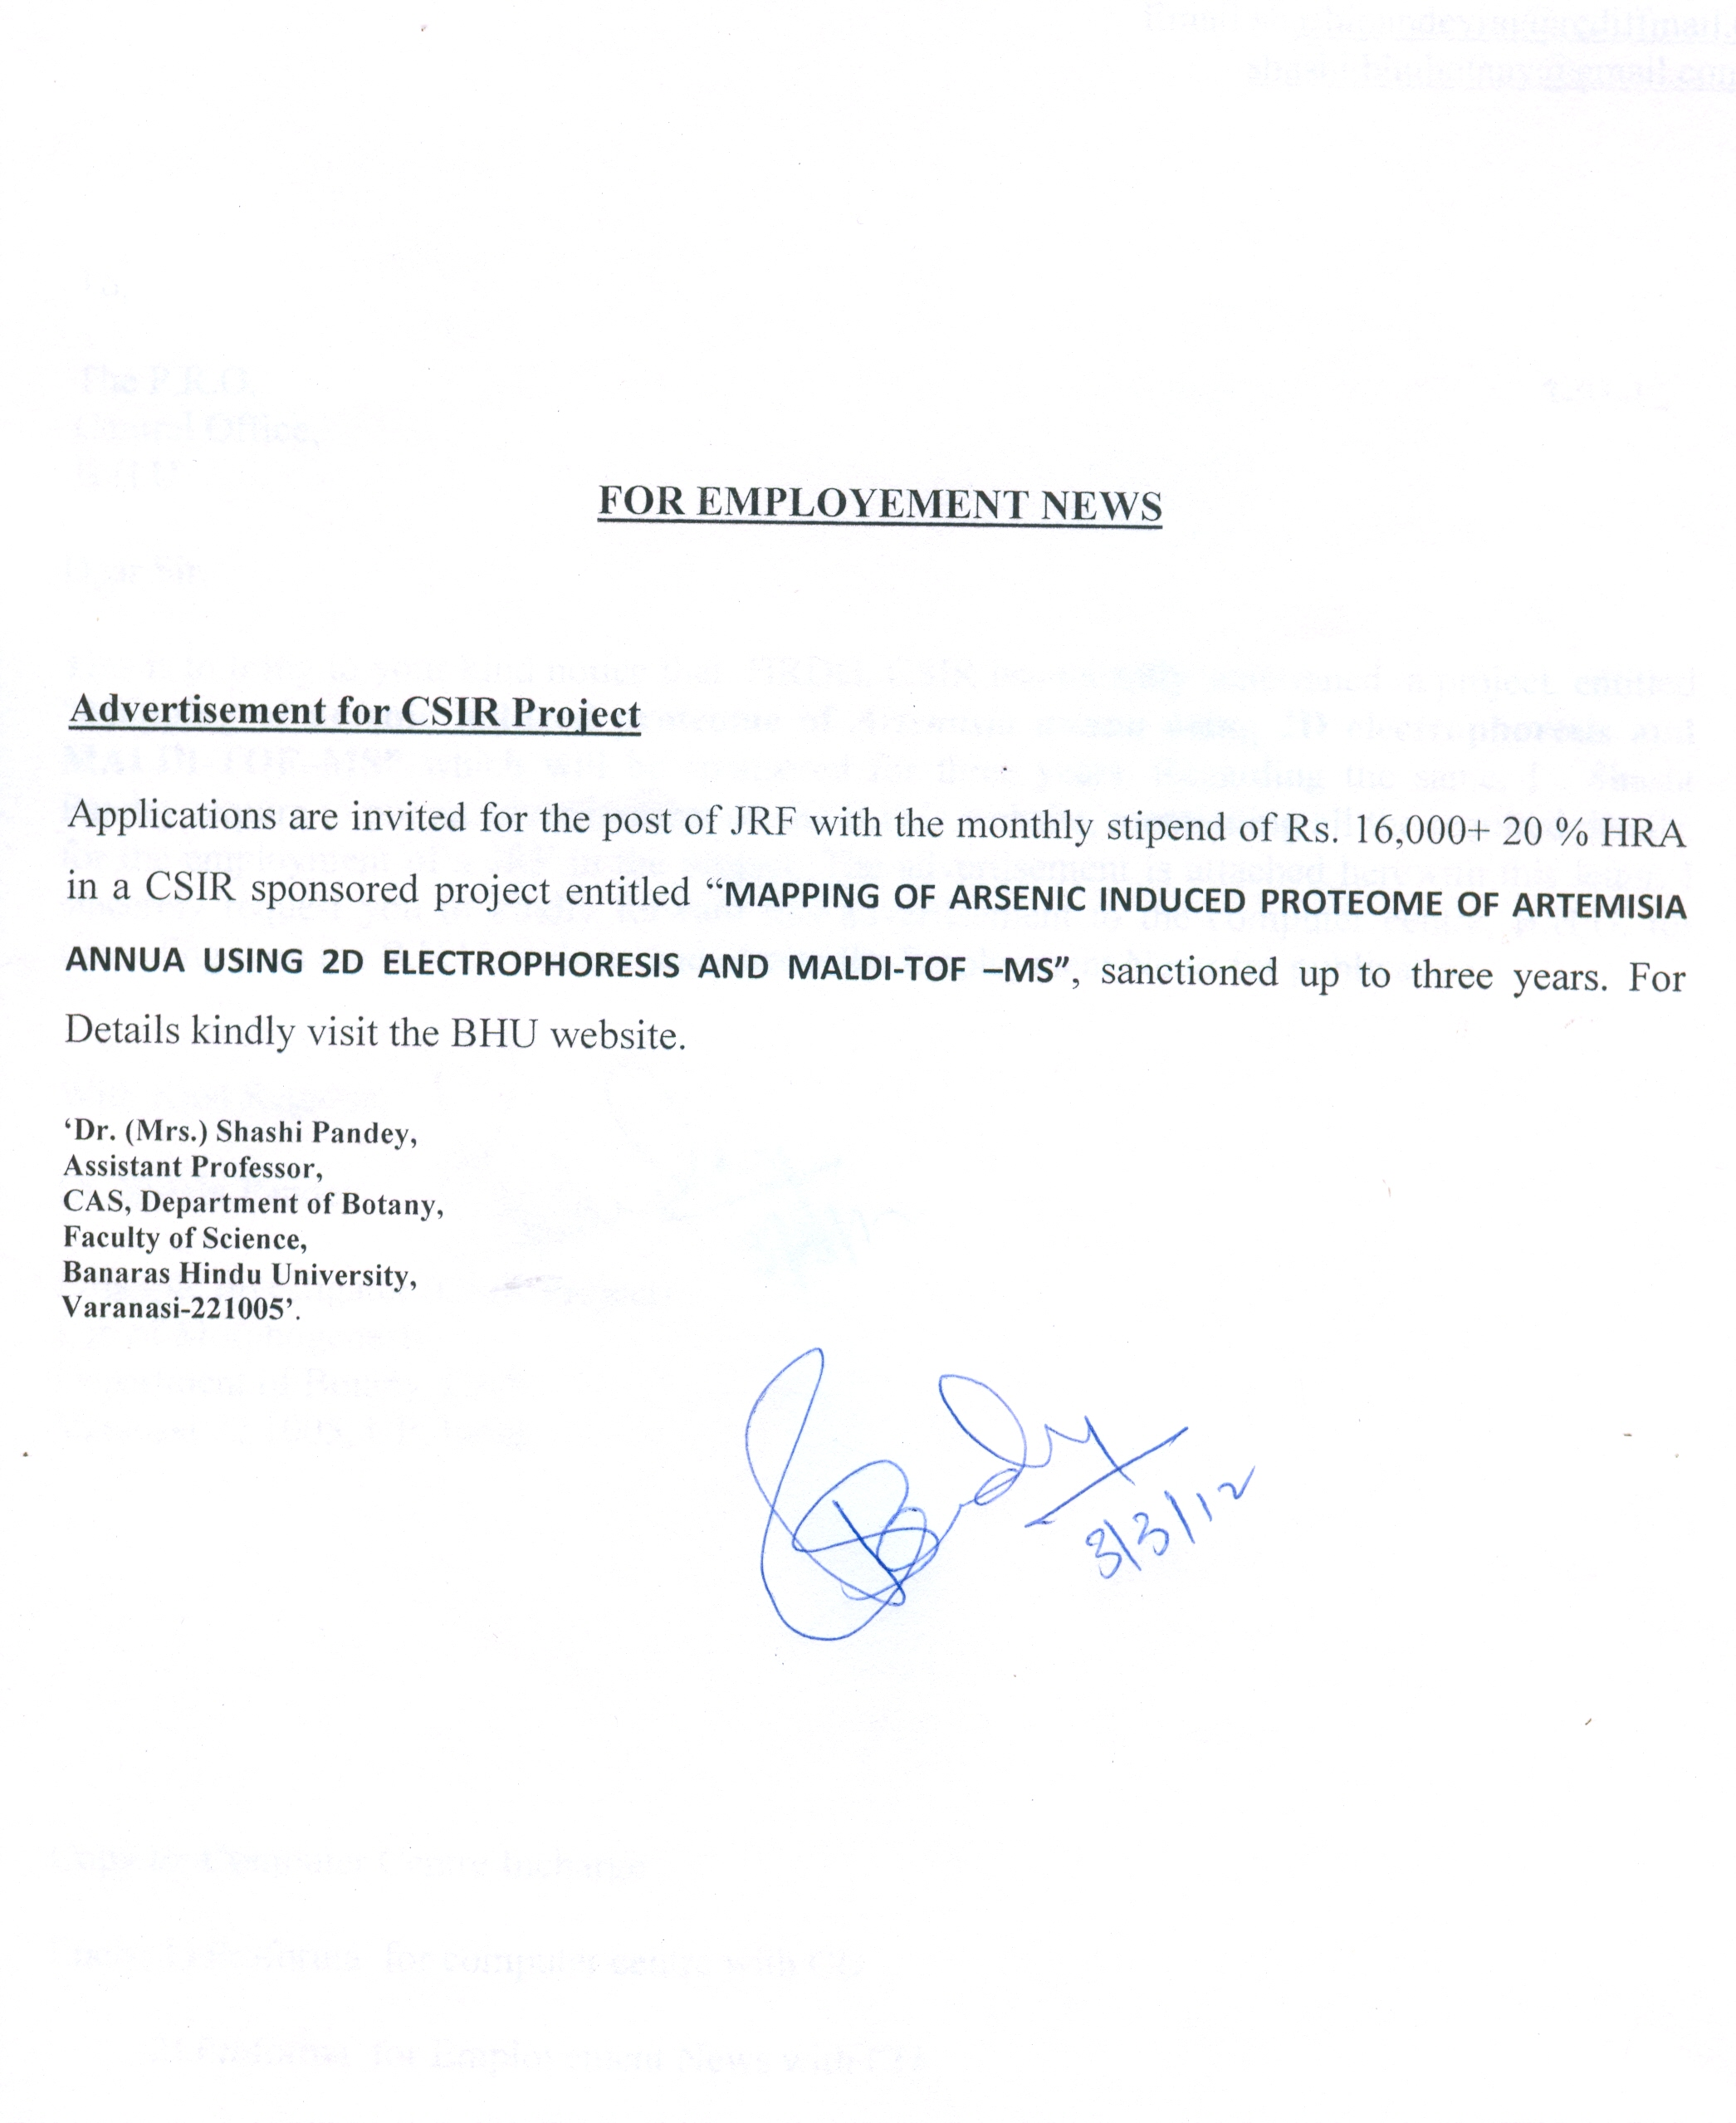
Dr. (Mrs.) Shashi Pandey, Assistant Professor, CAS, Department of Botany, Faculty of Science, Banaras Hindu University, Varanasi-221005
PI (CSIR- Project) Code- 25/329

