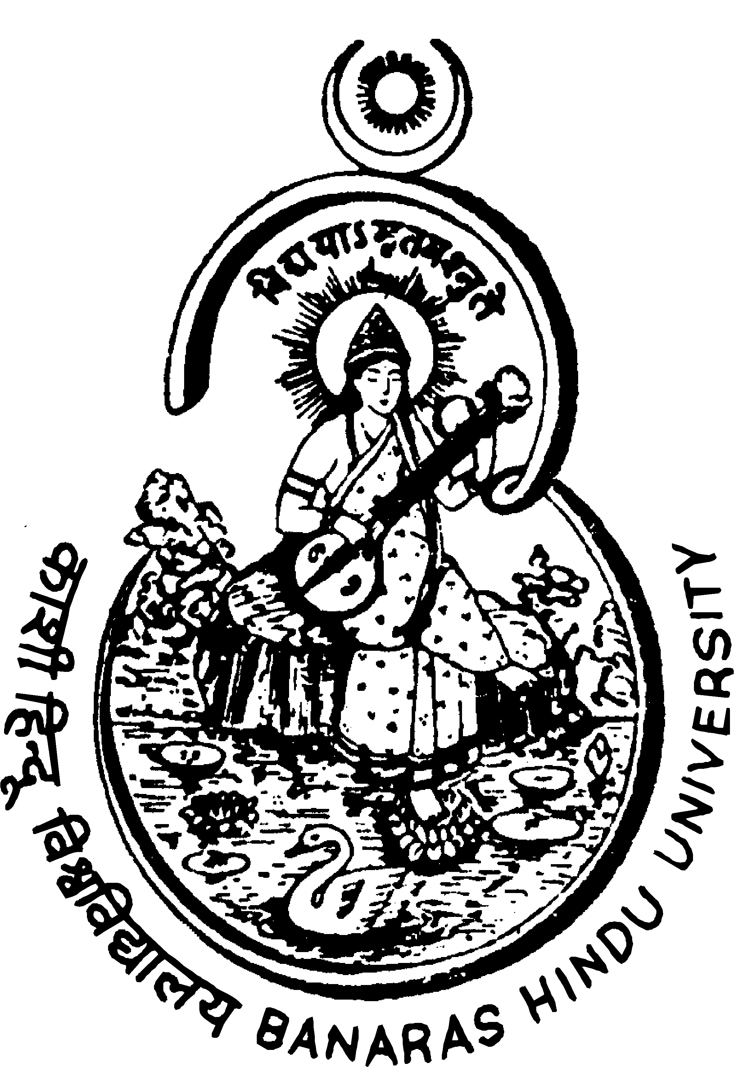
BANARAS HINDU UNIVERSITY,
VARANASI

EXTENSION OF DATE FOR NOTICE INVITING TENDER (NIT)
Last date for receiving tenders for (1) NIRO Spray Dryer System - Production Minor (2) Milk Processing Unit and (3) Fruit & Vegetable Processing Plant for the Centre of Food Science and Technology is extended to September 23, 2009.
Programme Coordinator
Centre of Food Science & Technology, Banaras Hindu University
Varanasi – 221 005 (UTTAR PRADESH)

