RETIRED TEACHERS

1. Name : Prof. D.A. Gangadhar
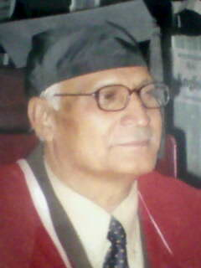
2. Date of Birth : 01.07.1945
3. Designation : Professor
4. Date of Retirement : 30 June-201
5. Area of specialization : Philosophy and Religion, Comparative Religion, Modern Indian Philosophy.
6. Publications : Books Published: Four and more than twenty papers
7. Email Address & Contact No. : 0542-2366294 (R) 09452074375 (M)
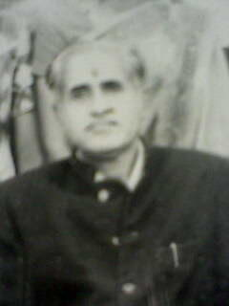

1. Name : Dr. R.S. Mishra

2. Designation : Professor

3. Area of specialization : Comparative Religion and Philosophy of Shri Aurobindo

4. Publication : Book i- The Integral Advaitism of Shri Aurobindo
ii. Zoroastrian Religion
by Prof. K.C. Chattopadhyaya (edited)
iii. Vedic Religion (edited)

- Email Address & Contact No. : 0512-2612927

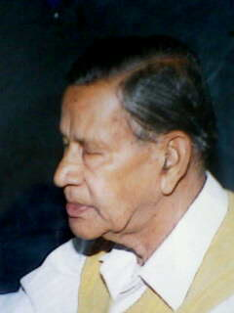

1. Name : Dr. A.K. Chatterjee

2. Designation : Professor

3. Area of specialization : Buddhism, Analytic Philosophy and Logic

4. Publications : Books- i. The Yogacara Idealism (1962)
ii. Readings on Yogacara Buddhism (1971)
iii. Facets of Buddhist Thought (1973)
iv. Saksi in Vedanta (1978)

5. Email Address & Contact No. : 0542-2314610

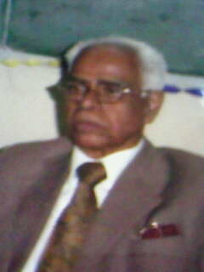

1. Name : Dr. N.S.S. Raman

2. Designation : Professor and Ex- Dean, Faculty of Arts.

3. Area of specialization : Phenomenology and Existentialism and Religious Studies.

4. Email Address & Contact No. : 0542-2417421



1. Name : Dr. L.N. Shrama

2. Designation : Professor

3. Area of specialization : Savism, Philosophy of Religion and Comparative Religion

4. Publication : Books- i- Dharma Dharsan (1972)
ii- Kashmir Savism (1972)

5. Email Address & Contact No. : Mob. No. 9414484348



1. Name : Dr. B.N. Singh

2. Designation : Professor

3. Area of specialization : Buddhism, Indian Logic and Epistemology

4. Publication : Books- i- Bhartiya Dharsan (Hindi)
ii- Paschatya Darsana (Hindi)
iii- Sabdabodha-vimarsah (Sanskrit)
iv-Indian Logic (English)
v- Dictionary of Indian Philosophical Concepts
(English)
vi. Vaisheshika Darsana

- Email Address & Contact No. : 0542-2366735



1. Name : Dr. Kamalakar Mishra

2. Designation : Professor

3. Area of specialization : Kashmir Savism

4. Publication : Books- i Significance of The Tantric Tradition,
Varanasi-(1981)
ii. Kashmir Savism: The Central Philosophy of
Tantrism.

4. Email Address & Contact No. : 0542-2311626
RETIRED TEACHERS (M.M.V.)



1. Name : Dr. (Miss) Bithika Mukherji

2. Designation : Lecturer


1. Name : Dr. M. Agrawal

2. Designation : Reader

3. Email Address & Contact No. : 9451644834

