Mahila Maha Vidyalaya

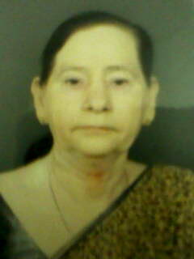
1. Name : Dr. Urmila Chaturvedi

2. Designation : Professor

3. Date of Birth : 13.05.1948

4. Date of Retirement : 31.05.2013

5. Email Address & Contact No. : 0542-2367871

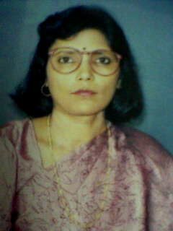
1. Name : Dr. Jyotshana Srivastava

2. Designation : Reader

3. Date of Birth : 05.05.1960

4. Date of Retirement : 31.05.2025

5. Email Address & Contact No. : Mobile No. 9452268627


1. Name : Shri Jai Singh

2. Designation : Lecturer

3. Date of Birth : 07.12.1973

4. Date of Retirement : 31-December- 2038

3. Email Address & Contact No. : 9956949404

