VALUE PROMOTION POLICY





BANARAS HINDU UNIVERSITY

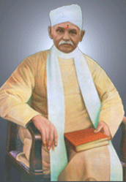

“A teaching university would but half perform its function if it does not seek to develop the heart-power of its scholars with the same solicitude with which it develops their brain-power. Hence it is that the proposed university has placed formation of character in youth as one of its principal objects. It will seek not merely to turn out man as engineers, scientists, doctors, merchants, theologists, but also as men of high character, probity and honour, whose conduct through life would show that they bear the hallmark of a great university”.

- Pt. Madan Mohan Malaviya
VALUE PROMOTION POLICY

PREAMBLE

Our National Policy on Education (1986) voices its concern over the declining value standard in society. To stem it, it calls for institution of an effective system of value education. The policy document states,

“The growing concern over the erosion of essential values and an increasing cynicism in society has brought to the focus the need for readjustment in the curriculum in order to make education a forceful tool for the cultivation of social and moral values.

In our culturally plural society, education should foster universal and eternal values, oriented towards the unity and integration of our people. Such value education should help eliminate obscurantism, religious fanaticism, violence, superstition and fatalism.

Apart from this combative role, value education has a profound positive content, based on our heritage, national and universal goals and perceptions. It should lay primary emphasis on this aspect.”

Our current national aspiration is to make India a developed country in the foreseeable future. We hope to emerge as a global power so as to occupy our rightful place in the comity of nations. Along with economic growth and material prosperity, we also want to build a social order which is humane, harmonious, just and egalitarian. This pressing nation building task demands growing input of highly educated and competent persons to run and lead the multifarious social and economic institutions of the modern Indian society. These persons come out of the portals of our universities and other institutions of higher learning. It is essential that in addition to the functional competence and technical skills, they should also possess a high degree of moral rectitude, and have a strong commitment to use their knowledge and skills for advancing social and human well-being. Hence it is essential that we institute a planned and structured system of value education to integrate social, moral and human values with our present system of higher education.

The Banaras Hindu University fully shares the concerns voiced by the National Policy on Education. Integrating ethics and human values with higher education was an important part of our founder, Mahamana Pt. Madan Mohan Malaviya ji’s vision for this university. Nurtured by this inspiring vision, the university feels it has a special responsibility to take effective steps for promoting value education. Accepting this responsibility the university has formulated and adopted this Value Promotion Policy for its guidance.

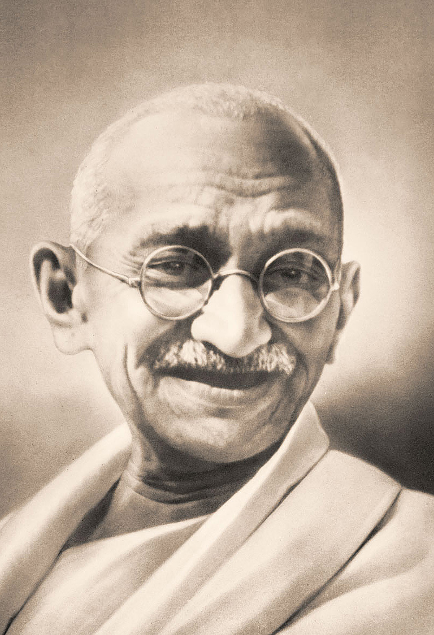

^^ml vkneh us lPph f’k{kk ik;h gS ftlds eu dh Hkkouk,¡ fcYdqy 'kq) gSWa ftls xyr dkeksa ls uQjr gS vkSj tks nwljksa dks vius tSlk ekurk gSA**

& egkRek xka/kh
PURPOSE

The purpose of this policy statement is to affirm our resolve to initiate effective measures for promoting ethics and human values as an integral part of university education. Towards this end, the policy outlines several programmes that the university plans to start for different segments of the university. The policy defines the general objectives of the programmes and the ways and means for operationalising them.

PROGRAMME

1. Student Focused Programmes
The main objective of value promotion amongst students is to help them grow up as ‘responsible’ citizens and ‘good’ human beings. Their world-view and life-view should not be limited only to their individual self and to their personal career advancement. Such a limited self-view leads to selfishness and exploitation of the society for personal gains. Therefore one goal of value education should be to help the student see that he/she belongs to the larger social, cultural and human orders. This sense of belongingness leads to acceptance of one’s moral responsibilities towards these larger wholes. With this orientation the student would be able to engage more positively and actively with the concepts of ethical and human values. This is not likely to happen if one attempts to inculcate or impose a set of preconceived values. Thus the effort should be to provide students with a conceptual framework which would enable them to appreciate the value of the ‘good’, of being ‘good’ and of doing ‘good’. To achieve this goal, different kinds of curricular and non-curricular programmes would be developed for the students, e.g.:

- A general course on ethics and human values, under the title, “uSfrd ,oa ekuoh; thou ewY;” for students of all disciplines.
- Specialised courses related to current values issues in different professional disciplines: e.g. engineering, medicine, management, etc.
- Specialised courses for research scholars on themes like, ethical issues in academic research and reporting.
- Encouraging and facilitating student participation in social service work and community projects.
- Non-formal workshops and seminars on values related themes, and value problems of modern life.


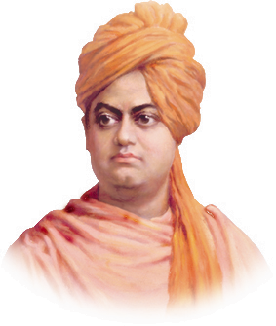

“The end of all education, all training should be man-making”.

- Swami Vivekanand
2. Faculty Focused Programmes
Formation of values in the students is highly affected by the value commitment of teachers, as reflected in their attitude and behaviour. Therefore, it is necessary that the value temper of the teachers should be of high order. They should also be more conscious of the need to act as exemplary ‘role models’ and ‘guides’ for the students’ personal growth, along with their academic growth. This objective can be achieved through suitably structured orientation workshops for teachers. Focus on these aspects could be a part of the programmes of the Academic Staff College.

The working of modern society, and its myriad institutions and organistions, throw up many challenging ethical and cultural value issues. Understanding their cause, their complex interrelationship, and possible ways of resolution, requires serious academic examination. Academics in the university should accept the responsibility for doing that. Therefore, teachers should be encouraged to take up ethical and human value issues of contemporary relevance as part of their academic research.

3. Administrator Focused Programmes
The administrative and financial powers of the university are exercised through academic administrators at different levels. The quality of academic work-culture and the value temper of teachers and students are much affected by the manner in which these powers are exercised. Therefore, it is important that the integrity, conscientiousness and the value temper of academic administrators be of a high order. Developing a value-based work culture in the University, by adapting an appropriate ‘code of conduct’ and practicing ‘exemplar activities’ in routine official works, is very important. Evolving workable ideas for the purpose, and mechanisms for their operationalisation, will also be a part of our value promotion policy.

4. Value Promotion Programmes Beyond the University
The locus of proposed activities as mentioned above lies primarily within the university. However being a central university of long standing with an all-India character we are also conscious of the university’s role of promoting ethics and human values in the larger society outside the university. To fulfill this role, focused workshops will be organized for different categories of professionals; corporate executives, engineers, doctors, civil servants, school teachers, etc. The university will also share its ideas and experiences in this area with other universities and institutions, so as to help and encourage them to start their own programmes of value education. Another area where the university could make a significant contribution is in generating concepts of social and ethical audit of different kinds of organizations, and devising methodologies for conducting such audits.

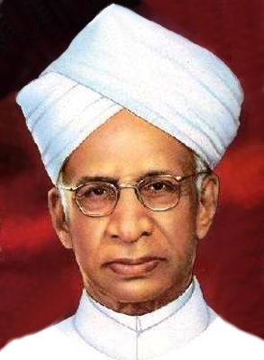

“Education is not limited to the imparting of information or training of skills. It has to give the educated a proper sense of values”.

- Sarvapalli Radhakrishnan

IMPLEMENTATION

Implementation of the programmes outlined in this policy will require a central nodal unit to coordinate and support the activities in different faculties and institutes of the university. Fortunately, the university already has such a unit in the form of ^ekyoh; ewY; vuq’khyu dsUnz* (Malaviya Centre for Ethics and Human Values). It was created in 1991, mainly for the purpose of discussing and debating issues related to the value problems of the modern life. Over the years the Centre has developed a couple of programmes for students and teachers of the university. To take upon the much bigger role envisaged in this policy statement, the Centre will be suitably strengthened.
Publication of books, journals, reports, news letters and other reading materials is an important activity for promotion of new academic programmes. It facilitates wider sharing of ideas and experiences amongst all those who are interested and engaged in the area of value education. Therefore, arrangements would be made to initiate an appropriate programme of publication.
Some of the value promotion programmes have already been operationalised in the university. For example, an effective non-formal workshop, with the title “thou ewY; ,oa ekuoh; {kerkvksa dk fodkl]” is being conducted for several years. It has found enthusiastic acceptance amongst the serious students of the university. Similarly, a bi-yearly journal, ^ewY;&foe’kZ* is being published regularly since last few years. These programmes would be further strengthened, expanded and coordinated with other activities envisaged in this policy.



