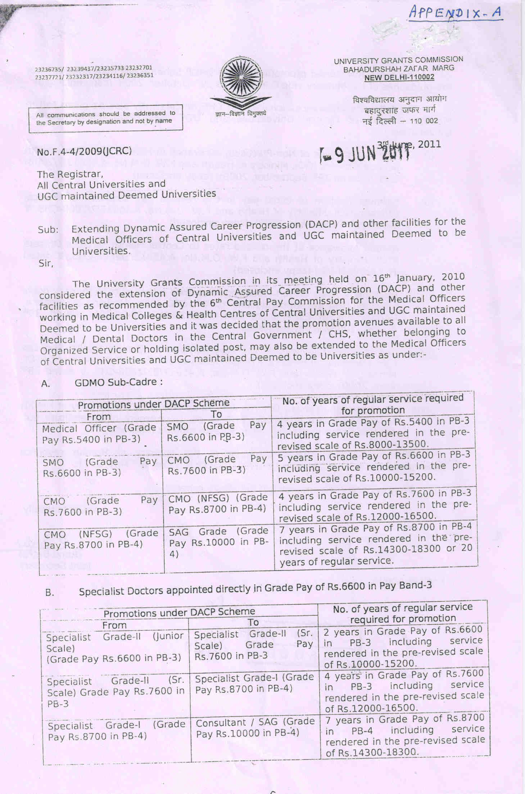

**APPENDIX-B**

|  |  |
| --- | --- |
|  | **dqylfpo dk;kZy;**  p;u ,oa vkadyu Ádks’B  **Office of the REGISTRAR**  Recruitment & Assessment Cell |

**APPLICATION-FORM**

**For placement/promotion under DACP Scheme as :**

1. From **Medical Officer (MO) to Senior Medical Officer** in the **Grade Pay** **Rs. 6600 in PB-3**
2. From **Senior Medical Officer to Chief Medical Officer** in the **Grade Pay** **Rs. 7600 in PB-3**
3. From **Chief Medical Officer to Chief Medical Officer** (NFSG) in the **Grade Pay** **Rs. 8700 in PB-4**
4. From **Chief Medical Officer(NFSG) to Senior Administrative Grade(SAG)** in the **Grade Pay**

**Rs.10000 in PB-4**

(**Tick √**  which is applicable)

Affix recent Passport Size Photograph with Signature

**(A) GENERAL INFORMATION**

(1) Name :

(2) Date of Birth :

(3) Father’s/Husband’s Name :

(4) Designation :

(5) Department/Centre/Unit :

(6) Address(Residential) :

**(B) ACADEMIC QUALIFICATION** (From Matric onwards):

|  |  |  |  |  |
| --- | --- | --- | --- | --- |
| **Examination** | **University** | **Subject** | **Year of Passing** | **Division/Grade** |
|  |  |  |  |  |
|  |  |  |  |  |
|  |  |  |  |  |
|  |  |  |  |  |
|  |  |  |  |  |
|  |  |  |  |  |
|  |  |  |  |  |
|  |  |  |  |  |

**P.T.O.**

**(C) EXPERIENCE**

|  |  |  |  |  |  |
| --- | --- | --- | --- | --- | --- |
| **Designation** | **Grade** | **Period**  ***From To*** | | **Institution/**  **Unit** | **Reason for leaving** |
|  |  |  |  |  |  |
|  |  |  |  |  |  |
|  |  |  |  |  |  |
|  |  |  |  |  |  |
|  |  |  |  |  |  |
|  |  |  |  |  |  |

**(D) DETAILS OF SERVICE**

1. Date of continuous appointment at BHU :

2. Date of substantive appointment :

3. Date of confirmation :

4. Total length of service :

5. Break in service (If any) :

6. Date of completion of

4 years as Medical Officer :

5 years as Senior Medical Officer :

4 years as Chief Medical Officer :

7 years as Chief Medical Officer(NFSG) :

or 20 years as regular service

7. Nature of duties:

(E) Training Programmes/courses etc. attended (Please attach sheet):

(F) Publications, if any (Please attach sheet):

(G) Innovation, if any (Please attach sheet) :

(H) Awards/Prizes/Medals/Recognitions etc. (Please attach sheet) :

**(I). Declaration-**  I declare that:

1. the information given above are complete and correct.
2. in case of concealment/suppression detected in future, of any fact(s), my application is liable to be rejected/ employment terminated as the case may be.
3. No disciplinary proceedings are pending or contemplated against me.
4. I will participate in all the Academic, extra-curricular and administrative programmes of the Department or the University as assigned to me failing which my /placement/promotion under DACP Scheme shall be withdrawn by the University at any point of time during my service period.

Date: Signature of Applicant

**­­­­­­­­­­**

**(To be filled in by the Office of the Head of the Department/Unit concerned, BHU)**

Date of receipt of application in the Office of the Head of the Department:

Certification by the Head of the Department/Unit

CERTIFIED THAT

1. Dr. . . . . . . . . . . . . . . . . . . . . . . . . . . . . has been working as . . . . . . . . . . . . . . . . . . . in this Department/Unit since . . . . . . . . .
2. the particulars given in the application form have been checked and verified from the Office records and are found to be correct.
3. the appraisal report about the work/performance, and conduct of the teacher will be sent shortly in a separate sealed cover.

DIRECTOR HEAD OF THE DEPARTMENT/UNIT

Signature with date Signature with date