Summer School on Development and Characterization of Advanced Materials
(Under UGC Networking Program)
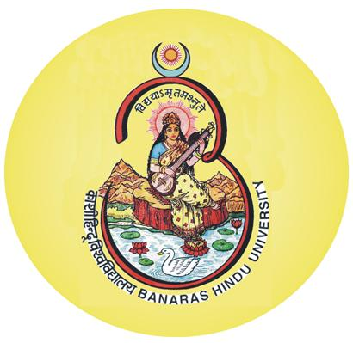
Physics Department, Banaras Hindu University,
Varanasi – 221 005, Utter Pradesh
Duration: February 22 – March 14, 2013

It is a pleasure to inform you that the Summer School on Development and Characterization of Advanced Materials sponsored by the UGC Networking Program, Government of India, will be hosted by the Physics Department of the Banaras Hindu University, Varanasi. The duration of the school will be three (03) weeks, starting on February 22 and ending on March 14, 2013. The purpose of organizing this school is to train the young researchers who intend to carry out research in the field of synthesis and characterization of advanced materials. All the lectures will be given by the expert scientists/teachers from all over the India at the basic level. Remember that as the tradition goes, on each working day there will be lecture periods followed by tutorial / lab hours. The school will focus on the following main topics:
METERIALS TO BE DISCUSSED:
Nanostructures and Nanocomposites; Quasicrystals; Photonic crystals; Chalcogenides; Materials for Energy; Multiferroic materials; Graphene; Carbon nanotubes and Fullerenes, Composite Polymers, Colloids and liquid crystals, Spintronic Materials, Spin Glass; Dilute Magnetic Semiconducting quantum dots; etc
EXPERIMENTAL TECHNIQUES:
TEM; SEM; EDX; STM, AFM, MFM & PFM; X-ray & Neutron Diffraction; XPS; EXAFS; Raman spectroscopy; Dielectric spectroscopy, TPS, DSC, DTA & TGA etc.
Final year/semester master students, young research scholars/ teachers, fresh Ph.D. students are encouraged to apply in the format prescribed below along with a recent passport size photo, so as to reach the convener/secretary of the school before February 10, 2013. If selected, a candidate will be provided free board and lodging, and (S)he will also be offered train fare (up to AC III tier) by the shortest route.

Prof. R.S. Tiwari Dr. Kedar Singh Dr. Neeraj Mehta
Convener Secretary Secretary

Email: ssdcam13@gmail.com

Summer School on DCAM’13
Physics Department, Banaras Hindu University, Varanasi 221005 (India)

Application form for participation in the Summer School on Development and Characterization of Advanced Materials
Department of Physics, Banaras Hindu University, Varanasi – 221 005
Duration: Feb 22 – March 14, 2013

Photo

1. Name of the applicant:
(Surname first)

2. Date of birth: 3. Male/Female:

4. Address for correspondence:
(With email and contact no.)

5. Academic qualifications:
S.No. | Examination passed | College/University | Year of passing | Subjects | % of marks with division/grade

6. Affiliation:
7. Supervisor’s Name:

8. Field of Research:
9. Teaching/ Research experience (If any)
10. List of publications (If any):

11. Whether accommodation required: YES / NO
12. Tentative date and time of arrival in BHU ………………………..

Date: Signature of Applicant
Place:

Note: Ph.D. and post-doc students are required endorsement (or recommendation) from the supervisor (by e-mail).

